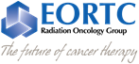Scientific Programme

**EORTC meeting for Radiation Therapy Technologists**

Monday, October 23, 2017

Zurich, Switzerland

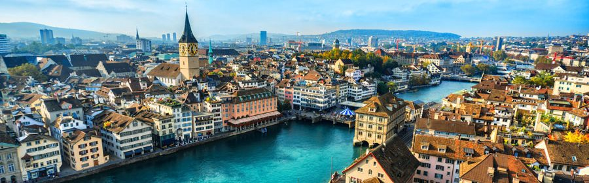

**Venue:**

University Hospital Zurich

Ramistrasse 100, 8091 Zurich, Switzerland



**CME accreditation 9 points**

**Registration fee € 30**

**Optional: Social dinner with ROG on Monday evening € 50**

**Registration deadline: 7 October 2017**

**For registration form and further details regarding venue, traveling and hotels, see website:**

[**http://www.eortc.org/event/radiation-oncology-group-meeting-4/**](http://www.eortc.org/event/radiation-oncology-group-meeting-4/)

**Scientific Committee:**

**Hans Paul van der Laan [h.p.van.der.laan@umcg.nl](mailto:h.p.van.der.laan@rt.umcg.nl)**

**Marjolein van Os** [**m.j.h.vanos@erasmusmc.nl**](mailto:m.j.h.vanos@erasmusmc.nl)

# **RT Technologists Subcommittee**

8.30 – 9.15 ***Registration and coffee (University building)***

**Session 1 Positioning verification**

*Chair: Frederique Cavelaars and Michal Walczak*

09.20 – 09.30 Opening and welcome

Hans Paul van der Laan / Marjolein van Os

*(Scientific Committee EORTC ROG RTT-section)*

09.30 – 09.50 Positioning accuracy of an optical surface monitoring device to reduce daily imaging of breast cancer patients

Floortje Brus

*(RT Technologist, USZ, Zürich, Switzerland)*

09.50 – 10.10 Image guided radiotherapy of prostate cancer patients

Dawid Bodusz

*(RT Technologist, Maria Skłodowska-Curie Memorial Cancer Center, Gliwice Branch, Poland)*

10.10 – 10.30An evaluation of GoldAnchor stability during stereotactic robotic radiosurgery (CyberKnife) of liver metastasis

Marek Podgorski

*(RT Technologist, Maria Skłodowska-Curie Memorial Cancer Center, Gliwice Branch, Poland)*

10.30 – 11.00 ***Coffee break (University building)***

**Session 2 Impact of new modalities in Radiotherapy**

*Chair: Sophie Perryck and Hans Paul van der Laan*

11.05 – 11.25 We keep an eye on it; treatment of uveal melanoma with Cyberknife

Marjan Faasse

*(RT Technologist, Erasmus MC Cancer Institute, Rotterdam, The Netherlands)*

11.25 – 11.45 Accuray Tomotherapy Hi-ART for prostate cancer:

a review of freedom from biochemical failure at 5-years when using 3-5mm planned target volume and MVCT Daily IGRT

Helen Summers - Lill

*(RT Technologist, Clinica Luganese, Lugano 6900, Switzerland)*

11.45 – 12.05 An Introduction into VERT - "The Flight Simulator for Linacs"

Tom Swayne

*(Radiotherapy Product Specialist, Vertual Ltd, UK)*

12.05 – 12.25 VERT for real in USZ

Foppe Jan Ent

*(RT Technologist, USZ, Zürich, Switzerland)*

12.30 – 13.30 ***Lunch (University building)***

**Session 3 Combining research and clinical practice in Radiotherapy**

*Chair: Floortje Brus and Maddalena Rossi*

13.30 – 13.50 How to get ideas and start your own research project?

Hans Paul van der Laan

*(Researcher, UMCG, Groningen, The Netherlands)*

13.50 – 14.10 SRS single fraction on multiple metastasis with BrainLab Elements Planning System using a TrueBeam sTx: how to ensure a high quality treatment delivery.

Luca Capone

*(RT Technologist, UPMC San Pietro, Rome, Italy)*

14.10 – 14.30 Abdominal SBRT in voluntary expiration, a feasibility study

Sophie Perryck

*(RT Technologist, USZ, Zurich, Switzerland)*

14.30 – 15.00 Custom care for palliative patients;   
Care, efficiency and research combined by a dedicated team

Marcella Cramer, Illona Steinvoort

*(RT Technologists, Erasmus MC Cancer Institute, Rotterdam, The Netherlands)*

15.00 – 15.30 **Joint session with ROG** *(Location: University building!)*

Guest speaker: Florian Lordick

*(Radiation oncologist, University Cancer Center Leipzig, Germany,   
Secretary EORTC GI Group)*

15.30 – 16.00 ***Tea break (University building)***

**Session 4 16.00 – 18.00 hrs, Delineation Project RTQA**

*Chair: Michal Walczak and Bruno Speleers*

16.00 – 16.20 EORTC RTQA Delineation Project:   
Improving volume definition of OAR within the EORTC Lungtech trial

Maddalena Rossi

*(Research Technologist, NKI, Amsterdam, The Netherlands)*

16.20 – 18.00 **Delineation Workshop**: ***EORTC 1308 ROAM - Meningioma trial***

**Bring your laptop!!**

*or*

**Departmental tour USZ**