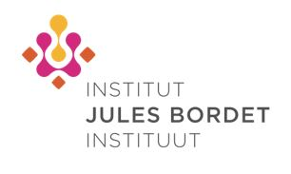

4th Human Cancer Immunology Course for Oncologists and Scientists Thursday 4 & Friday 5 October, 2018
Location : Pullman Brussels Centre Midi (Place Victor Horta 1, 1060 Brussels)

REPLY FORM
☐ Mr./Mrs ☐ Professor ☐ Doctor  First Name:  Hospital:  City : | INAMI/RIZIV n°:  Family Name:  Department :  Email:

I will attend on Thursday 4th October 2018  I will attend on Friday 5th October 2018 | YES ☐ NO☐  YES ☐ NO☐
Please return your response by August 20th to P. Adam / N. Gautron (+32 (0) 2 541 32 06) by email: martine.piccart@bordet.be
or by fax +32(0) 2.538.08.58
For all information please contact P. Adam or N. Gautron : +32 (0) 2 541 32 06 or martine.piccart@bordet.be
Institut Jules Bordet, Medicine Department 121 Boulevard de Waterloo 1000 Brussels

